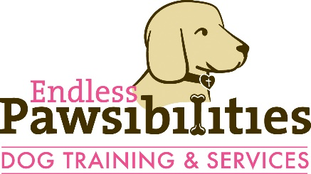LLC
SITTING AND TRAINING WAIVER/ RELEASE AGREEMENT
This agreement and the rules within have been established to better protect and serve you and your dog(s), other Owner(s) and their dog(s), and Endless Pawsibilities Dog Training & Services LLC employees and assigns. Please take this into serious consideration as you read the following.
By signing the Sitting & Training Waiver/ Release Agreement you are acknowledging that you have read, understand, and consent to the terms stated here-in.
I, ________________________(owner/keeper/harborer printed name) (hereinafter “Owner”), certify that I have been informed and understand that there are unavoidable risks of injury involved when working with animals and I acknowledge that dogs can be inherently difficult to control, especially dogs with behavioral issues. As the owner, I have a duty to disclose any behavioral issues known to me, and can be found to be negligent, intentionally liable, and/or strictly liable if I fail to disclose behavioral issues of which I am aware to Endless Pawsibilities (including their agents, contractors, assistants, and employees) (hereinafter “Trainer”) in order to mitigate the risk of injury to Trainer, myself, my dog, my family members, and others. Trainer agrees to exercise reasonable care to prevent injuries or damages that can reasonably be anticipated, and reserves the right to decline providing services which could result in foreseeable harm.
I hereby accept and assume, without reservation, all risks associated with using Endless Pawsibilities services, except those arising from gross negligence or willful misconduct on the part of Endless Pawsibilities, and including, but not limited to: the risks of any and all injuries to myself, my dog, and any of my family members or third parties who may attend trainings and to any damage to property; the risk of illness to my dog; the risk that my dog may cause injury to other persons and/or dogs. I accept responsibility for costs incurred due to damages, illness, or injury caused by my dog or to my dog.
I, the Owner, hereby waive, release, discharge, indemnify, defend and hold harmless, and agree not to sue Endless Pawsibilities from any and all injuries, losses, claims and damages to any person or persons of any nature whatsoever, including claims arising from the Owner’s own negligence, and all costs associated therewith, including attorney’s fees, court costs and consultant fees, arising from my use of Trainer’s services.
No waiver or modification of any provision herein shall be valid unless expressly agreed to in writing by both the Released Party and the Releasing Party. Every provision herein is intended to be severable. If any one or more of the provisions herein is found to be unenforceable or invalid, that shall not affect the other terms and provisions hereof, which shall remain binding and enforceable.
This Sitting & Training Waiver/ Release Agreement shall be legally binding on the Owner. Should the Owner assert a claim to the contrary to what has been established by the terms herein, the Owner shall be liable for all expenses (including attorney’s fees, court costs and consultant fees) incurred by both the Owner and the Trainer.

Signature: _____________________________ date: _________________

