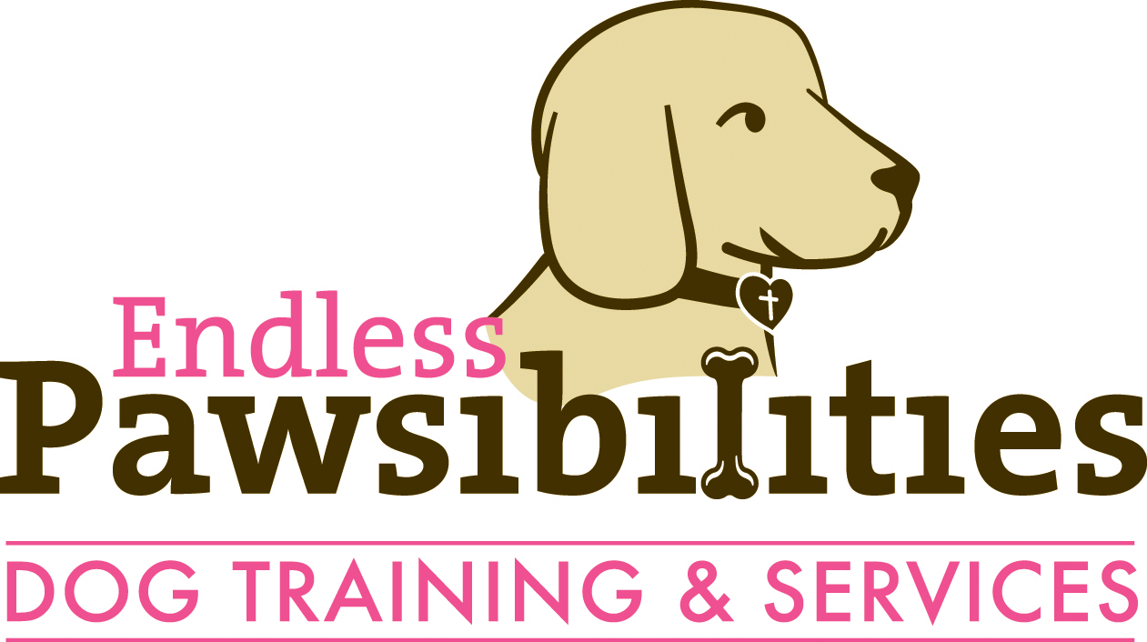
Endless Pawsibilities Dog Training & Services LLC (EP) prioritizes safety to the business, dogs under the care of EP, the owner, and the public at large. In recognition of the serious consequences that could result from failing to address issues related to a dog’s behavior, the following statutes/ordinances specific to Colorado are being provided to protect you and your dog with information concerning the expectations of the law:

Definition of Dangerous Dog
According to C.R.S. 18-9-204.5. 2
(b)Dangerous dog" means any dog that:
(I) Inflicts bodily or serious bodily injury upon or causes the death of a person or domestic animal; or
(II) Demonstrates tendencies that would cause a reasonable person to believe that the dog may inflict bodily or serious bodily injury upon or cause the death of any person or domestic animal.

Definition of Harassing Dog
Pitkin County 5.04.100: HARASSING DOGS
For the purpose of this section, any dog that chases, snaps at, or bites a person or another animal or has demonstrated tendencies that would cause a reasonable person to believe that the dog may inflict injury upon any person or animal. No owner or keeper of a dog shall permit the dog to harass any other animal or person. A dog shall be deemed harassing whether or not the offending dog inflicts injury. § 5.04.100 added Ord. 009-2016)

I, ______________________, understand/ realize that my dog has exhibited aggressive behavior and have described the pertinent situation(s) openly and honestly to EP in order to best protect the safety of all involved.
Initials: ________
Accordingly, EP has explained to me the necessity/ importance of:
- adequately securing my dog with leash and collar or harness when out in public or in private when another dog or person could be bitten
- restraining my dog with a muzzle anytime the dog is around people/ dogs s/he is not known to get along with
- carrying a deterrent: Spray Shield (Citronella), Pet Corrector, or Mace to keep other dogs at bay or to interrupt a fight.
Additionally, being in the care, custody, and control of a dog known to be vicious imposes further duties such as the obligation to warn those present and segregate the dog from people and other dogs.

I understand that my compliance, consistency, and commitment to safety, management, and control of my dog is of utmost importance. Changing a behavior or emotion in an animal takes time and requires compliance, consistency, and commitment to the behavior modification program. Initials: ________

If the dog injures the trainer, the client will pay reasonable medical bills and compensation for loss of income as the law so allows. Initials:________

Printed Name:______________________________
Signature:_________________________________ Date:_______________

